CIS 4374 Semester Project - Smart Parking Platform
Vision, Scope, and Software Requirements Specification (SRS)
Project: Smart Parking Platform
Version: 3.2 (Draft)
Date: October 8th, 2026

Contents
CIS 4374 Semester Project - Smart Parking Platform 1
1. Project Research for Existing Software: 4
How Will the Smart Parking Application We Are Building Be Different? 5
2. Project Vision and Scope 5
2.1 - Company Introduction 5
2.2 - Project Overview 5
2.3 - Project Acquisition Description 5
2.4 - Scope 6
2.5 - Users 6
3. Overall System Description 7
3.1 - Overall System Description 7
3.2 - Project Management Plan 7
3.3 - Project Constraints 7
3.4 - High Level Project Requirements 7
4. Functional Requirements 7
5. Non-Functional Requirements 8
6. Draft of SRS with Use Cases 9
7. Project Planning 11
7.1 - Work Breakdown Structure (WBS) - Complete Task List 11
7.2 - Project Timeline - Gantt Chart 13
7.3 - Smart Parking Platform Backlog (Jira) 14
7.4 - Smart Parking Sprint 1 Backlog and Plan (Jira) 16
8. Communication Plan 18
8.1 - Meeting Cadence 18
8.2 - Reporting Processes and Methods 19
8.3 - Stakeholder Communication Responsibilities 19
8.4 - Communication Tools 20
9. Risk Management 20
9.1 - Risk Categories 20
9.2 - Risk Register 22
10. Resources and Cost Management Plan 23
10.1 - Roles and Resources 23
Roles Description Table 23
Roles and Resources Planning Tables 24
10.2 - Resources and Cost Plan (Bottom-Up Cost Plan) 25
10.2.1 - Labor Costs 25
10.2.2 - Non-Labor Costs 25
10.2.3 - Base Project Cost 26
10.2.4 - Contingency 26
10.2.5 - Total Estimated Project Cost 26
10.3 - High Level Cost Plan 27
10.4 - Monthly Cashflows 28
10.5 - RACI Matrix 29
10.6 - Resource and Cost Management Assumptions 30

1. Project Research for Existing Software:
During the research phase of this project, I saw that were a number of existing software solutions that try to address issues with parking. Existing software solutions like ParkMobile, SpotHero, Passport Parking, and Easy Park. The following table will go into more detail about these existing solutions.
Existing Parking Platform Software Solutions
Solution | What The App Does | Strengths | Weaknesses/Limitations
ParkMobile | - Parking lookup  - Mobile Payments  - Parking Availability  - Parking Management Tools  - Digital Tools | - Large parking network  - Large user base  - Supports on-demand and reservations in advance  - Parking Availability info and tools to manage pricing | - Reservation availability depends heavily on the specific parking facility  - Availability feature is not available in every location  - Paywall for some features
SpotHero | - Parking Lookup  - Reservations  - Parking Passes  - Reservation Modification  - Event Parking | - Strong reservation capabilities  - Users can modify reservations before they start | - Reservations don’t guarantee a parking space  - In & Out privileges can vary by facility  - Availability and features can depend on parking partners
Passport Parking | - Mobile Payments  - Parking Maps  - Update Notifications  - Reporting Dashboards  - Parking Operator Tools  - Remote Extensions | - Strong operator capabilities  - Combines payments, reporting, enforcement, and customer parking services | - Primary focus is on mobile payment rather than navigation experience, which is more important to the customers  - Depends on integration with other parking platforms
Easy Park | - Parking Payments  - Parking Lookup  - Navigation Assistance  - Predictive/Probability for getting parking space | - Heavy focus on helping people locate parking  - Uses real-time data and probability estimates to direct users to open spots | - Predictions are probabilities rather than guarantees for the availability of specific parking spots

Key Points: The existing solutions for this use show that this industry already has some apps that have strong capabilities. However, there is room for improvement for each one, which our application could excel in.

How Will the Smart Parking Application We Are Building Be Different?
After reviewing the existing software solutions for a Smart Parking Platform, it is evident that there is opportunity for differentiation between our application and their applications. The plan for this Smart Parking Platform is going to combine real-time data, parking reservations, navigation, seamless payments, adequate notifications, and more functionality for operator-side functions. Using real-time data for parking spot occupancy can provide more information to customers for more reliable estimates and availability. This application will differentiate itself from these existing solutions by connecting real-time data on availability, reservations, interactive maps, notifications, and more. This platform will directly support this project’s high-level requirements for things like availability, reservation capabilities, payments, navigation, notifications, and administrative tools. The experience on this app will be more unified, seamless, intuitive, and useful for the potential userbase.

2. Project Vision and Scope

2.1 - Company Introduction
WE ARE $oftware ¢orp is a software development studio that aims to provide seamless solutions to issues customers may have. The company has an unlimited budget and resources that will allow it to get together development teams and the technologies to support their projects. The goal for this project is to develop a project management plan for the creation of a Smart Parking Platform system.

2.2 - Project Overview
The proposed Smart Parking Platform is being created to address the issue regarding people spending too much time trying to get parking. There is also a need for parking operators to have more efficient ways to manage occupancy, pricing, and utilization. For this project, there is a huge emphasis on real-time availability, interactive maps, reservations, payments, analytics, receipts, notifications, management tools, and more. The goal is to develop a project management plan for the creation of this system, including requirements gathering, stakeholder management, scheduling, budgeting, management, and team coordination. Even though there is an unlimited budget, there are several constraints like a fixed timeline, third party dependencies, compliance with privacy and similar requirements, and city & ordinance laws. The scope of this project will be updated throughout the semester.

2.3 - Project Acquisition Description
This Smart Parking Platform project was acquired by WE ARE $oftware ¢orp through a competitive approval proposal that was initiated by a city transportation department who wants to improve parking availability, improve reservation capabilities, reduce traffic, and to increase the utilization of parking facilities. There was (RFP) Request for Proposal for a web and mobile platform that can provide real-time parking availability, reservations, payments, navigation, and management tools. Because of WE ARE $oftware ¢orp’s technical approaches and project management capabilities, we were selected to develop the solution. The project will be developed with an unlimited budget and resources but must be done within the timeline.

2.4 - Scope
In Scope
- User Registration and Authentication
- Parking Querying and Real-Time Availability
- Interactive Parking Map
- Parking Facility Information
- Parking Reservations
- Digital Payment Processing
- Reservation History and Receipts
- Notifications
- Operator Dashboard
- Reporting and Analytics
- Integration of External Systems
- System Integration and Testing
- Web and Mobile Applications
Out-of-Scope
- Parking Infrastructure
- Deployment of Parking Sensors
- Hardware Deployment
- Parking Enforcement
- Management of Parking Facilities

2.5 - Users
- Customers, Users, Those in need of Parking Spaces in Public Spaces
- Parking Facility Facilitators

3. Overall System Description

3.1 - Overall System Description
The application is a software system that helps drivers locate, reserve, and pay for parking spaces for parking garages in real time. The platform will be available through web and mobile applications and will provide parking availability information, navigation help, and management tools for parking operators. The application is going to include a web application and mobile application, reporting dashboards, payments, reservations, notifications, and external integrations.

3.2 - Project Management Plan
We are creating a project management plan for the creation of this system, including gathering requirements, resource and cost management, managing communication between stakeholders, scheduling the project, budgeting the project, managing the risks that come with the project, and coordinating all the teams involved.

3.3 - Project Constraints
- Unlimited theoretical development budget
- Fixed semester timeline
- Dependence on third-party services and APIs
- Compliance with security and privacy requirements, city ordinance & laws

3.4 - High Level Project Requirements
- User Registration and Authentication
- Real-Time Parking Space Availability
- Interactive Map Displaying Available Parking Locations
- Parking Reservation Capability
- Digital Payment Processing
- Reservation History and Receipts
- Administrative Dashboard for Parking Operators
- Occupancy Reporting and Analytics
- Notifications
- Integration with External Navigation and Mapping Services
- Simple and Intuitive User Controls and Interfaces

4. Functional Requirements
Functional Requirements
- FR1: The system shall allow users to register and log in securely.
- FR2: The system shall display real-time parking availability.
- FR3: The system shall display parking locations using an interactive map.
- FR4: The system shall allow users to search for parking facilities.
- FR5: The system shall allow users to view parking facility details and pricing.
- FR6: The system shall allow users to reserve a parking space.
- FR7: The system shall allow users to make digital payments on the application.
- FR8: The system shall notify users of parking through sending out parking notifications.
- FR9: The system shall allow users to modify parking reservations.
- FR10: The system shall allow users to quit on their parking reservations.
- FR11: The system shall monitor parking occupancy in certain locations.
- FR12: The system should provide navigation assistance to users.
- FR13: The system shall allow users to monitor parking occupancy at a given location.
- FR14: The system shall allow users manage parking facilities.
- FR15: The system shall create or generate occupancy reports and display data dashboards.

5. Non-Functional Requirements
Non-Functional Requirements
- NFR1: The system shall support at least 1,000 concurrent users.
- NFR2: The system shall display updated parking availability within 5 seconds of receiving new occupancy data.
- NFR3: The system shall provide a simple and intuitive interface for viewing and reserving parking spaces
- NFR4: The system shall be available on commonly used web browsers and mobile devices.
- NFR5: The system shall provide reliable access to parking availability, reservations, and payments.
- NFR6: The system shall respond to standard user requests within 3 seconds in normal operating conditions.
- NFR7: The system shall safekeep user account information from unauthorized access and control.
- NFR8: The system shall encrypt sensitive data stored within the system.
- NFR9: The system shall maintain system performance when processing real-time parking availability, occupancy updates, and more.
- NFR10: The system shall be scalable to support increase in users, parking facilities, occupancy data, and reservations.

6. Draft of SRS with Use Cases
Use Cases
Use Case 1
Title: Register Account
Actor: Customer
Precondition: User does not have an account
Steps: User enters required information and submits registration.
Postcondition: A user account is created.
Use Case 2
Title: Log In
Actor: Customer
Precondition: User has an account
Steps: User enters valid credentials and selects “Log In.”
Postcondition: User is authenticated.
Use Case 3
Title: Find Available Parking
Actor: Customer
Precondition: User has access to the platform
Steps: User enters a destination and views available parking.
Postcondition: Available parking options are displayed.
Use Case 4
Title: View Parking Map
Actor: Customer
Precondition: Parking locations are available
Steps: User opens the map and selects a parking location.
Postcondition: Selected parking facility is displayed.
Use Case 5
Title: View Parking Details
Actor: Customer
Precondition: Parking facility is selected
Steps: User views availability, pricing, and facility information.
Postcondition: Parking information is displayed.
Use Case 6
Title: Reserve Parking Space
Actor: Customer
Precondition: User is logged in and parking is available
Steps: User selects a time and confirms the reservation.
Postcondition: Parking is reserved.
Use Case 7
Title: Make Digital Payment
Actor: Customer
Precondition: User has a reservation
Steps: User selects a payment method and submits payment.
Postcondition: Payment is processed and recorded.
Use Case 8
Title: View Reservation History
Actor: Customer
Precondition: User has reservations
Steps: User opens reservation history and selects a reservation.
Postcondition: Reservation details are displayed.
Use Case 9
Title: Receive Parking Notification
Actor: Customer
Precondition: User has an active reservation
Steps: System detects a relevant event and sends a notification.
Postcondition: User receives the notification.
Use Case 10
Title: Modify Reservation
Actor: Customer
Precondition: User has an eligible reservation
Steps: User changes the reservation details and confirms the change.
Postcondition: Reservation is updated.
Use Case 11
Title: Cancel Reservation
Actor: Customer
Precondition: User has an eligible reservation
Steps: User selects “Cancel” and confirms cancellation.
Postcondition: Reservation is cancelled.
Use Case 12
Title: Get Parking Directions
Actor: Customer
Precondition: Parking facility is selected
Steps: User selects “Get Directions.”
Postcondition: Navigation directions are provided.
Use Case 13
Title: Monitor Parking Occupancy
Actor: Parking Operator
Precondition: Operator is logged in
Steps: Operator opens the dashboard and views occupancy information.
Postcondition: Current occupancy is displayed.
Use Case 14
Title: Manage Parking Facility
Actor: Parking Operator
Precondition: Operator has management privileges
Steps: Operator updates parking availability or rates and saves changes.
Postcondition: Facility information is updated.
Use Case 15
Title: Generate Occupancy Report
Actor: Parking Operator
Precondition: Occupancy data is available
Steps: Operator selects a reporting period and generates a report.
Postcondition: An occupancy report is available for review.

7. Project Planning

7.1 - Work Breakdown Structure (WBS) - Complete Task List
These images show the high-level overview of the project timeline with the WBS created in Microsoft Project.
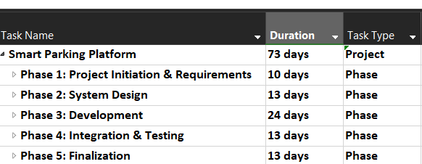
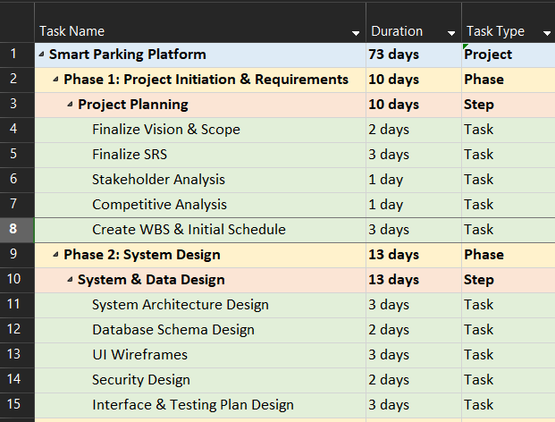
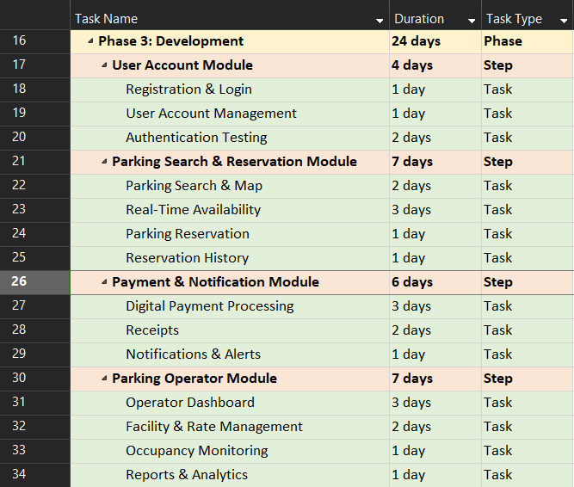
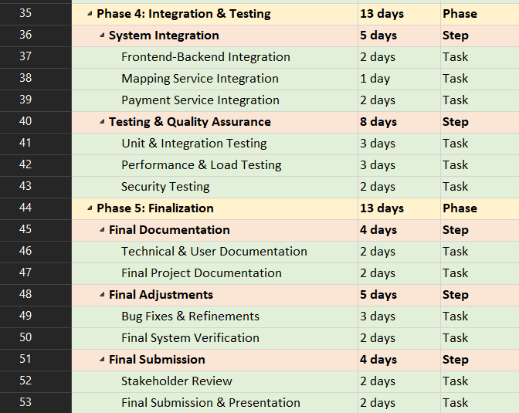

7.2 - Project Timeline - Gantt Chart
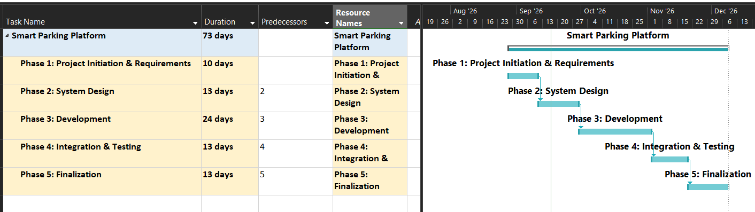
The Gantt chart below sums up the project schedule across five phases and a 73-day total duration.

7.3 - Smart Parking Platform Backlog (Jira)
Smart Parking Platform Jira Project
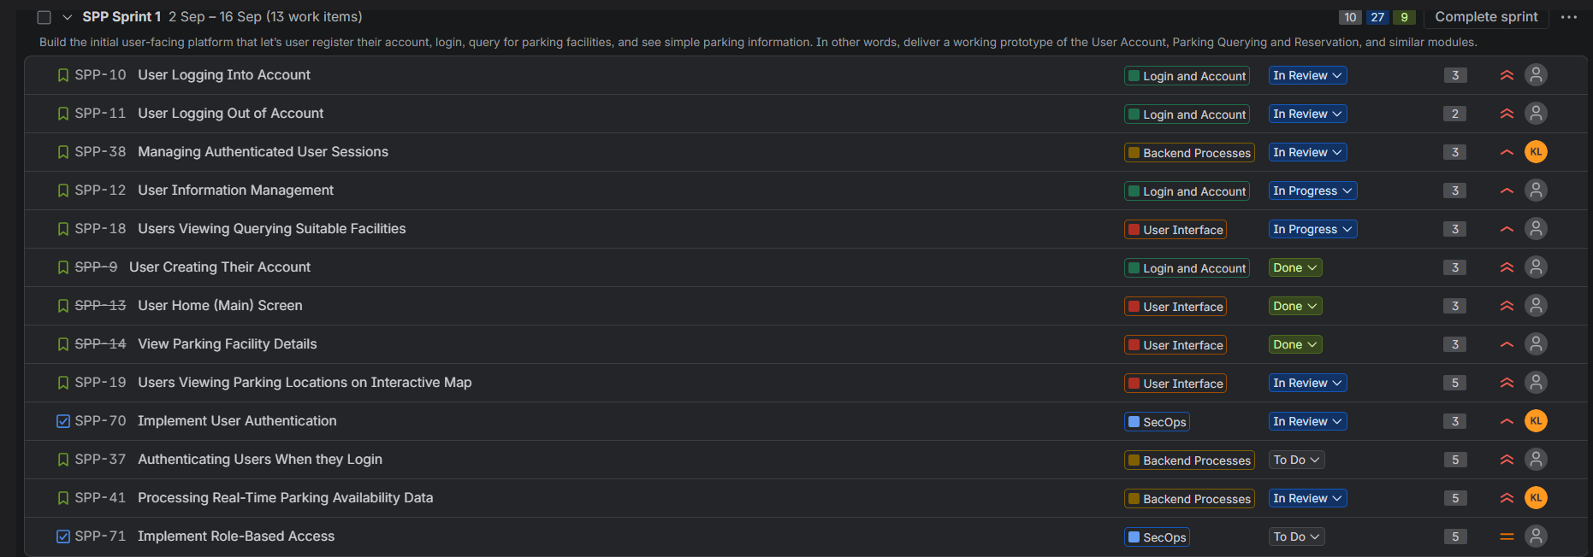

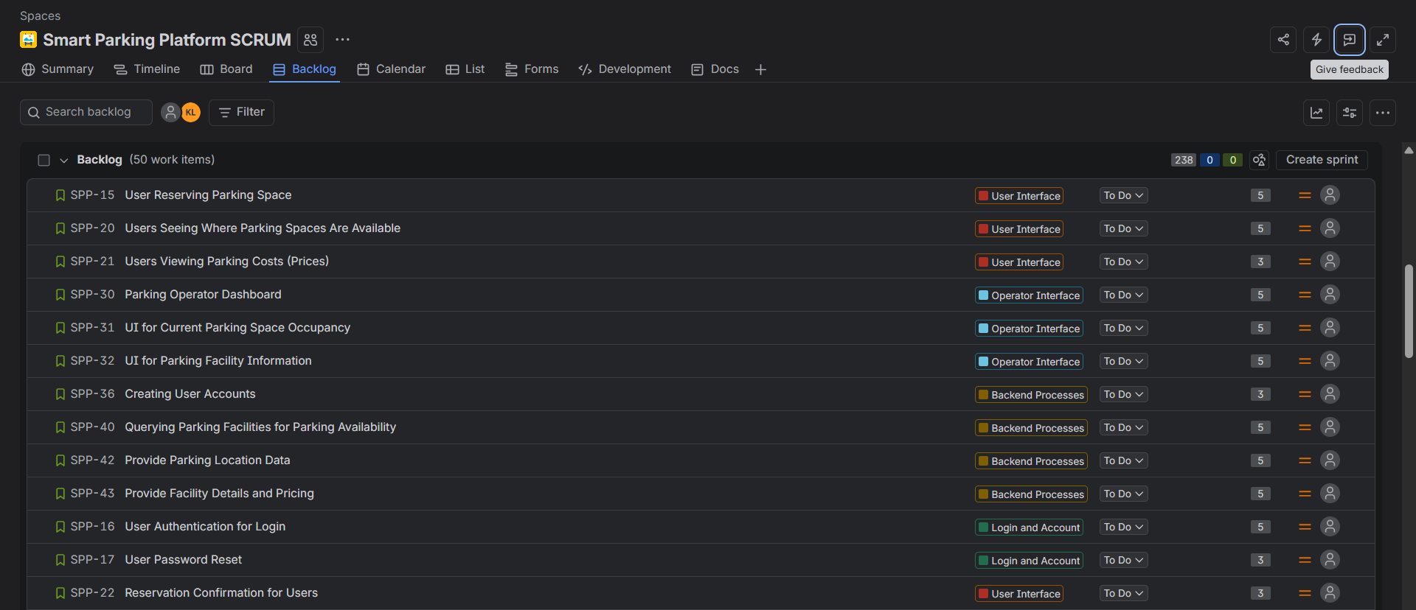
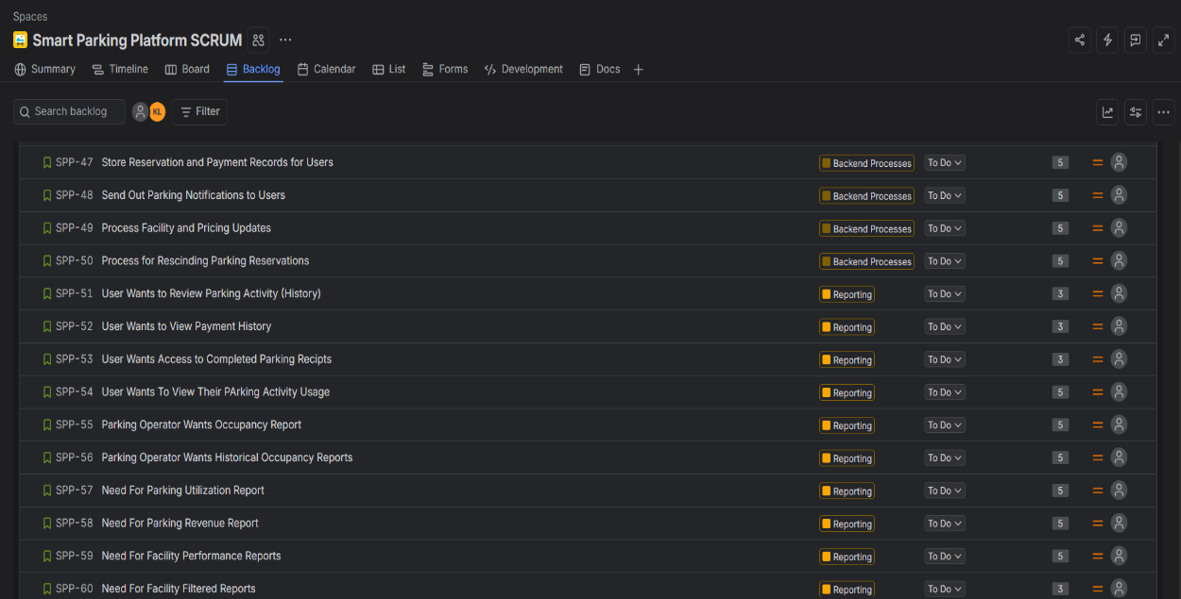
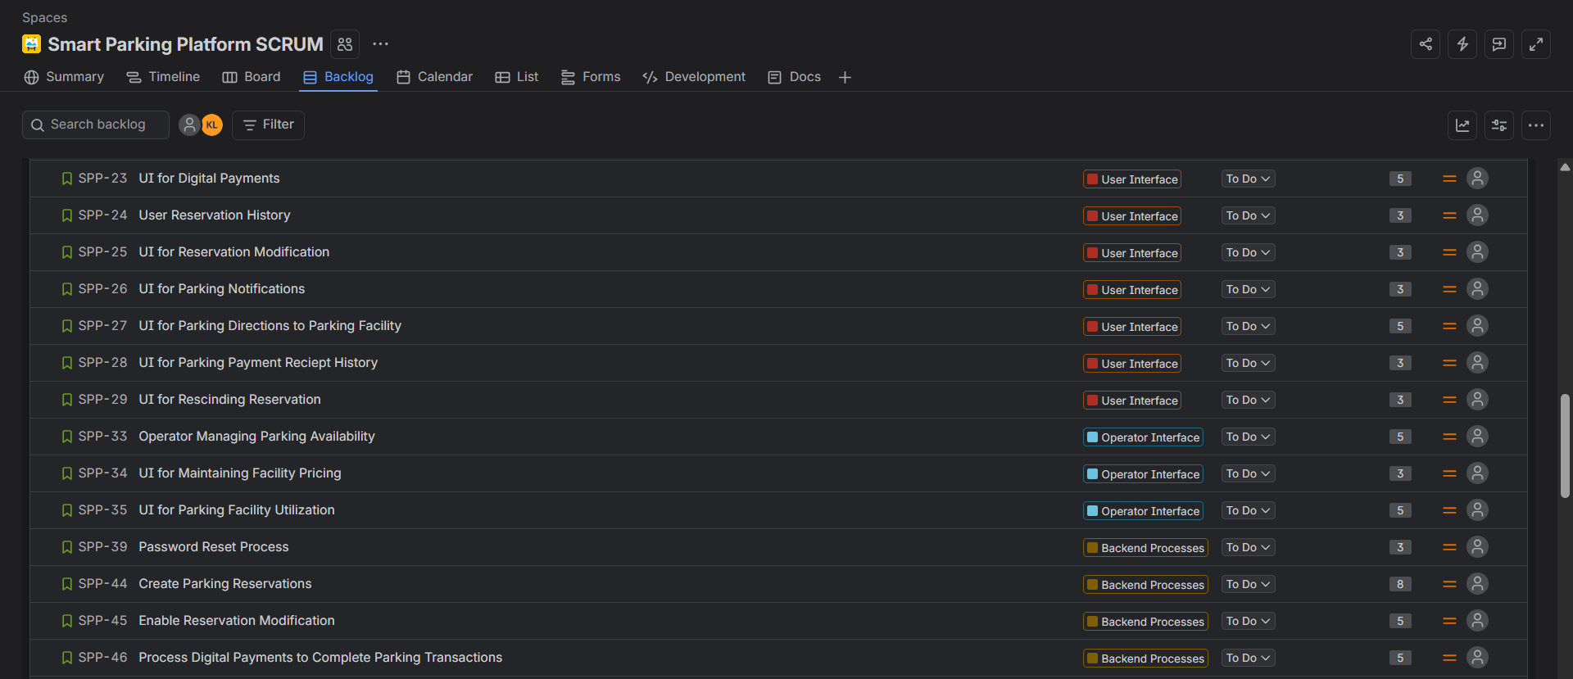

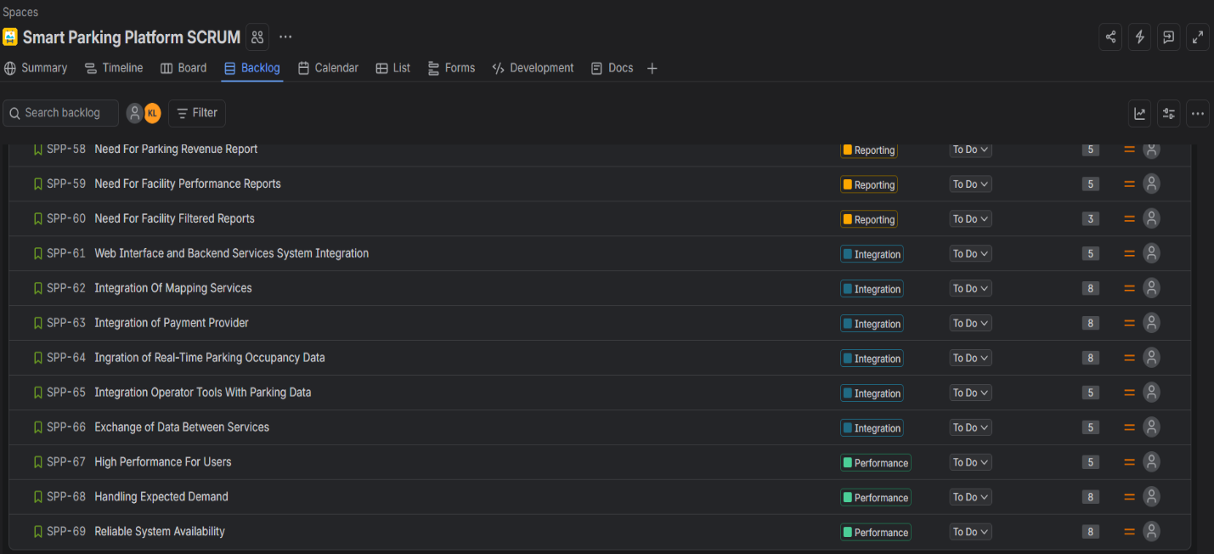

7.4 - Smart Parking Sprint 1 Backlog and Plan (Jira)

Sprint 1: Build the initial user-facing platform that let’s user register their account, login, query for parking facilities, and see simple parking information. In other words, deliver a working prototype of the User Account, Parking Querying and Reservation, and similar modules.
Duration: ~2 Weeks (15 days)
Sprint ID | ID | Task | Assigned To | Status | Story Points
SPP-9 | LOGIN-01 | User Creating Their Account | Auth Team | Done | 3
SPP-10 | LOGIN-02 | User Logging Into Account | Auth Team | In Review | 3
SPP-11 | LOGIN-03 | User Logging Out of Account | Auth Team | In Review | 2
SPP-12 | LOGIN-04 | User Information Management | Auth Team | In Progress | 3
SPP-13 | UI-USER-01 | User Home (Main) Screen | UI Team | Done | 3
SPP-14 | UI-USER-02 | View Parking Facility Details | UI Team | Done | 3
SPP-18 | UI-USER-04 | Users Viewing Querying Suitable Facilities | UI Team | In Progress | 3
SPP-19 | UI-USER-05 | Users Viewing Parking Locations on Interactive Map | UI Team | In Review | 5
SPP-37 | BE-PRO-02 | Authenticating Users When They Login | Backend Team | To Do | 5
SPP-38 | BE-PRO-03 | Managing Authenticated User Sessions | Backend Team | In Review | 3
SPP-41 | BE-PRO-06 | Processing Real-Time Parking Availability Data | Backend Team | In Review | 5
SPP-70 | SEC-01 | Implement User Authentication | SecOps Team | In Review | 3
SPP-71 | SEC-02 | Implement Role-Based Access | SecOps Team | To Do | 5

8. Communication Plan
The following communication plan will establish how the development teams, project leadership, and stakeholders will communicate progress, share updates, report issues, and coordinate work with each other.

8.1 - Meeting Cadence
Meeting Type | Frequency | Participants | Purpose/Goals
Daily Stand Up (Async) | Daily by 10:00 AM | Dev Team, Scrum Master | Each member posts what they’ve done in Teams/Slack, what is planned for today, and whatever blockers they may have.
Weekly Stand Up (SCRUM, Synchronous) | Weekly | Project Manager, Scrum Master, Representative from Each Dev Team | Review the progress of the current sprint, review risks/blockers, and plan for the upcoming week. Meeting notes should be stored in shared project repository.
Weekly Stakeholder Check-In | Weekly | Project Manager, Stakeholders, Product Owner, Relevant Team Representatives | Present a sprint demo to stakeholders and provide project status update. Record feedback and add relevant items to Product Backlog.
Sprint Planning | Beginning of Each Sprint | Product | Establish the goals for the next sprint, select backlog items to be worked on, estimate effort using story points, and assign responsibilities.
Sprint Retrospective | Conclusion of Each Sprint | Scrum Team | Internally discuss what went well, what the team could improve on, and make adjustments for the next sprint.
Sprint Review | Conclusion of Each Sprint | Project Manager, Scrum Team, Product Owner, Stakeholders | Display completed functionality, collect feedback, and review progress toward the project’s goals.
Project Communication Note: The daily stand up is asynchronous, so team members don’t need to join a meeting. They just need to post their updates by 10 AM each day. However, if the scrum master feels that there needs to be video calls, they can do so. The main channels of communication will be through Microsoft Teams and Slack.

8.2 - Reporting Processes and Methods
Reporting Method | Frequency | Information Communicated | Escalation Path
Jira | Continuously | Tracks backlog, sprint progress, task ownership, and whatever blockers. | Team Scrum Master
Project Report Status | Weekly | Report milestones, schedule, progress, and the risks. | Project Manager
Microsoft Project | Weekly | Update WBS, Gantt Chart, dependencies, and milestone changes. | Project Manager
Slack | Daily / As Needed | Share daily stand-ups, questions, and whatever blockers. | Scrum Master Project Manager
Microsoft Teams | Scheduled Meetings / As Needed | Hold video meetings, sprint prototypes, and stakeholder check-ins. | Project Manager
Shared Project Repository | Update Continuously | Store meeting minutes, decisions, documentation, and status reports for cross-team access and viewing. | Project Manager
Escalation Rules: Whatever issues can push back sprint commitments, project milestones, and sensitive information should be reported immediately rather than waiting until the next team meeting.
Escalation Path: Team Member Team Lead Scrum Master Project Manager

8.3 - Stakeholder Communication Responsibilities
Role | Responsibilities
Project Manager | Maintain the project schedule, status reports, and stakeholder communication. Facilitate team meetings, ensure sprint deliverables are delivered on time, and communicate updates and prototypes to stakeholders.
Product Owner | Communicate requirements for the product, emphasize the importance of the Backlog, and specify and clarify user needs.
Scrum Master | Facilitate Scrum events, coordinate communication with Dev Team, and help resolve blockers.
Development Team Leads | Report team progress, technical issues, be engaged with team, and coordinate with cross-team collaboration/dependencies.
Team Members | Post daily stand ups, attend meetings, complete deliverables, keep up with Jira, and flag blockers.
Project Documentation Note: Use Jira as the main source of truth for backlog and sprint matters, Microsoft Project for the overall schedule.

8.4 - Communication Tools
Tool | Usage
Slack | Communication channels for daily asynchronous stand-up updates, quick questions, and questioning potential blockers.
Microsoft Teams | Video meetings, weekly team meetings, stakeholder check-ins, screensharing for sprint prototyping, and another channel of communication between project members.
Jira | Product Backlog, Sprint Planning, Task Assignments, and Progress Updates.
Microsoft Project | WBS, Gantt Chart, project schedule, and milestone progress.
Shared Project Repository | Meeting minutes, project documentation, decision-making, technical updates, and status reports.
Email | Channel of communication when forwarding messages to entire teams.

9. Risk Management

9.1 - Risk Categories
Technical Risks |
- TR1: Third Party Mapping/Navigation 3rd Party mapping or navigation APIs may become unavailable, which could limit the user’s ability to navigate to parking facilities or receive instructions to them.
- TR2: Inaccurate Real-Time Parking Data Real-time parking data could be delayed or inaccurate, which could lead to users trying to reserve spacings that are no available at that point in time.
- TR3: Application Integration Issues The web, mobile, and background modules could have integration issues, which could cause certain features to not work across platforms, which could then cause user downtime.
- TR4: Insufficient Payment Gateway Integration The payment gateway integration may not process transactions correctly, meaning payments could not go through and records could be off.
- TR5: Scalability Issues The app could face scalability issues if thousands of users are using it simultaneously, especially with all the features and API integrations that are being used in it.

Schedule Risks |
- SR1: Tasks Take Longer Than Expected Development tasks may take longer than initially estimated which could delay sprint goals and project milestones.
- SR2: Scope Creep Changes to requirements may broaden the scope which could put additional work on the team that will make the project exceed the initial timeline.
- SR3: Delayed Stakeholder Feedback If the stakeholders don’t review deliverables in a timely manner, it could hold the team back from moving on, delaying overall project progress.
- SR4: Third Party API Access and Approval If the 3rd Party API access and approval is delayed, then project progress might be delayed due to the need for testing the APIs within the application as well as the integration of those APIs.
Financial Risks |
- FNR1: Third-Party Mapping Service Fees Some 3rd Party and Location services might incur usage fees, which could contribute to large operation expenses, especially as usage builds up.
- FNR2: Large Payment Transaction Fees Payment gateway providers could charge expensive transactions fees, which could hike up the cost of processing parking payments.
- FNR3: Infrastructure Costs The technical resources needed to host, run, and serve the application could introduce large infrastructure operating costs, especially if they exceed initial estimates (Cloud hosting, database usage, servers, etc.).
- FNR4: Additional Testing or Development Resources \The project could require more funding and resources than initially expected, especially if there needs to be new hardware or software purchases.
Note: While the company may have an unlimited theoretical development budget, it is still important to consider financial implications regarding this project.
People Risks |
- PR1: Lack of Communication Development teams not being on the same page, which could lead to components and modules being incompatible with one another and very distinct interfaces.
- PR2: Team Member Drops Out Team members could drop out or not be available for their own reasons which could delay the completion of development tasks, especially if they owned important path tasks.
- PR3: Unclear Task Ownership Unclear task ownership could result in incomplete or duplicated work which slows down sprint progress, commitments, and the completion of deliverables.
- PR4: Lack of Experience with Certain Technologies Team members could lack experience with certain technologies or lack the competencies for certain tasks, which could lead to the need for additional training and even implementation errors which could delay sprint progress.

9.2 - Risk Register
Legend:
TR = Technical Risk
SR = Schedule Risk
FNR = Financial Risk
PR = People Risk
ID | Description | Probability | Impact | Owner | Response Strategy | Status
TR3 | Application Integration Issues | High | Very High | Backend/API Team | Conduct integration testing throughout development. | In-Progress
TR2 | Inaccurate Real-Time Parking Data | Medium | Very High | Backend/API Team | Validate parking pace data and implement timely availability updates. | In-Progress
TR1 | Third Party Mapping/Navigation Issues | High | Very High | Mapping Team | Identify mapping options and test API access in timely manner. | In-Progress
SR4 | Issues with Third Party API Access and Approval | Medium | High | Integration Team | Request access to APIs in timely manner and use mock services or made-up data in the meantime. | In-Progress
SR2 | Scope Creep | Medium | Medium | Product Owner | Consult with Product Owner to review scope and make changes in Backlog. | In-Progress
SR1 | Tasks Take Longer Than Expected | High | Medium | Scrum Master and Team | Review progress during daily stand-up and keep Sprint backlog up to date. Ensure key deliverables are being worked on. | In-Progress
PR1 | Lack of Communication | Medium | High | Scrum Master and Teams | Hold regular coordination meetings outside of and during scrum and keep shared documentation up to date. | In-Progress
PR4 | Lack of Experience with Certain Technologies | Medium | Low | Technical Leads | Provide technical knowledge, knowledge sessions, and workshops to help team get used to certain technologies. | In-Progress
FNR3 | High Infrastructure Costs | High | Medium | Backend/API Team | Monitor resource consumption and configure resource utilization notifications. Confirm that the application workflows, resources, and processes are properly optimized. | In-Progress
FNR1 | High Third-Party Mapping Service Fees | Low | Low | Project Manager | Monitor API usage and review provider pricing and usage limits. Compare and contrast with other possible providers that have the same service(s). | In-Progress

10. Resources and Cost Management Plan

10.1 - Roles and Resources

Roles Description Table
The following table details the team members and teams that have been assigned to the Smart Parking Platform application. This details the roles within the project.
Role / Team | Primary Responsibilities
Project Manager | Schedule, budget, risk management, stakeholder communication, and project coordination.
Product Owner | Product requirements, backlog importance ranking, and stakeholder needs.
Scrum Master | Scrum events, team coordination, blockers, process improvement.
Technical Lead / Lead Architect | Architecture, technical decisions, and cross-team technical collaboration and dependencies.
Mobile Application Team | Mobile application development, mobile UX.
Web Application Team | Web application development, responsive UI and UX
Backend/API Team | Backend services, API integration, database, authentication, and business logic.
Mapping / Services Team | Mapping, geolocation, parking locations, navigation functionality.
Payment Integration Team | Payment processing and payment service integration.
QA and Testing Team | Functionality, integration, performance, reliability, and system testing.
SecOps Specialist | Authentication, authorization, privacy, confidentiality, SecOps testing.

Roles and Resources Planning Tables
The following HR Plan Table details the team members and teams that have been assigned to the Smart Parking Platform application. The Smart Parking Platform will use a Scrum-Based structure of project leadership, technical leadership, developments teams, and a SecOps resource. Every name in this project is fictitious.
Role / Team | Name | Skill Level | FTE% | Hours / Month | Hourly Rate | Monthly Cost
Project Manager | Mitch Carter | Senior | 50% (0.50) | 80 | $65 | $5,200
Product Owner | Sarah Davis | Senior | 40% (0.40) | 64 | $60 | $3,840
Backend/API Team | Ryan Patel | Senior | 100% (1.00) | 160 | $65 | $10,400
Technical Lead / Lead Architect | Alex Kipp | Senior | 75% (0.75) | 120 | $75 | $9,000
Mobile Application Team | Noah Goff | Intermediate | 100% (1.00) | 160 | $55 | $8,800
Web Application Team | Ava Davis | Intermediate | 100% (1.00) | 160 | $55 | $8,800
Scrum Master | Greg Brooks | Senior | 50% (0.50) | 80 | $55 | $4,400
Mapping / Services Team | Jordan Chang | Senior | 100% (1.00) | 160 | $63 | $10,080
Payment Integration Team | Ethan Myers | Senior | 100% (1.00) | 160 | $65 | $10,400
SecOps Specialist | Jared Poe | Senior | 50% (0.50) | 80 | $70 | $5,600
QA and Testing Team | Sophia Ramirez | Senior | 100% (1.00) | 160 | $50 | $8,000
Totals | 11 Resources |  |  | 1,384 | $84,520

Important Assumptions: 100% FTE is equivalent to 160 working hours per month. The percentages represent the portion of each resource’s available working time going towards this project. The hourly payments are market estimates for software professionals.
Total Estimated Hours (Monthly) | 1,384 Hours
Estimated Labor Cost (Monthly) | $84,520

10.2 - Resources and Cost Plan (Bottom-Up Cost Plan)
The following tables will detail the Resource and Cost plan that utilizes the bottom-up cost estimation approach for the Smart Parking Platform. The costs are calculated and summed based off estimates for roles, labor, non-labor, tools, and additional resources that are relevant. There is also a 15% contingency that is applied to the base project cost to account for unexpected costs, scope changes, and similar thingss

10.2.1 - Labor Costs
The HR Plan has 11 project resources with a combined estimated workload of 1,384 hours per month and total monthly labor cost of $84,520.
Resource Category | Monthly Cost | Four-Month Cost (Monthly Cost × 4)
Project Management, Product Ownership, Scrum Master | $13,440 | $53,760
Technical Leadership | $9,000 | $36,000
Development Teams | $48,480 | $193,920
QA and Testing | $5,600 | $22,400
SecOps | $8,000 | $31,200
Total Labor Cost | $84,520 | $338,080

10.2.2 - Non-Labor Costs
These are the non-labor costs that are associated with this project.
Resource Category | Monthly Estimate | Four-Month Cost (Monthly Cost × 4)
Cloud Hosting and Database | $2,000 | $8,000
Mapping and Location APIs | $1,500 | $6,000
Payment Integration and Testing | $1,000 | $4,000
Software & Development Tools | $1,500 | $6,000
SecOps and Privacy Compliance | $1,000 | $4,000
Legal & Regulatory Compliance | $1,000 | $4,000
Employee Training | $500 | $2,000
Total Non-Labor Cost | $8,500 | $34,000

10.2.3 - Base Project Cost
The base project cost includes the costs of labor and non-labor expenses before contingency.
Cost Component | Four-Month Cost
Labor | $338,080
Non-Labor | $34,000
Total Labor Cost | $372,080

10.2.4 - Contingency
There will be a 10% contingency applied to the base project to account for unexpected costs, scope changes, and similar things.
$372,080 × 10% = $37,208
Contingency = $37,208

10.2.5 - Total Estimated Project Cost
Cost Component | Four-Month Cost
Labor | $338,080
Non-Labor | $34,000
Base Project Cost | $372,080
Contingency (10%) | $37,208
Total Project Cost | $409,288

10.3 - High Level Cost Plan
This table shows the high-level bottom-up cost plan for the project.
Item Category | Cost Type | Qty/Months | Unit Cost | Duration (Months) | Total
Project Labor | Labor | 5,536 Hours | $61.07/hr (AVG) | 4 | $338,080
Cloud Hosting and Database | Infrastructure | $2,000/month | $2,000 | 4 | $8,000
Mapping and Location Services | APIs | $1,500/month | $1,500 | 4 | $6,000
Payment Integration and Testing | Integration | $1,000/month | $1,000 | 4 | $4,000
Software and Development Tools | Tools | $1,500/month | $1,500 | 4 | $6,000
SecOps and Privacy Compliance | Compliance | $1,000/month | $1,000 | 4 | $4,000
Legal and Regulatory Compliance | Compliance | $1,000/month | $1,000 | 4 | $4,000
Employee Training | Training | One-Time | $2,000 | 4 | $2,000
Contingency (10%) | Reserve | 10% | Applied to Base Cost | Not Applicable | $37,208
Total | $409,288

10.4 - Monthly Cashflows
This table shows the project monthly expenditures across the 4-month project. It includes labor costs, non-labor costs, and contingency reserves.
Month/Phase | Labor | Non-Labor | Base Cost | Contingency (10%) | Total
Month 1 - Planning and Design | $70,000 | $6,500 | $76,500 | $7,650 | $84,150
Month 2 - Development | $85,000 | $8,500 | $93,500 | $9,350 | $102,850
Month 3 - Integration and Testing | $95,000 | $10,500 | $105,500 | $10,550 | $116,050
Month 4 -SecOps, QA, and Deployment | $88,080 | $8,500 | $96,580 | $9658 | $106,238
Total | $338,080 | $34,000 | $372,080 | $37,208 | $409,288
Note: The contingency reserve is divided into 4 parts in the table, however, it can change based on its actual need. It is not fixed to the number in the table, but instead these are just estimates based on the phase of the project. In theory, the entire contingency dollar amount ($37,208) is going to sit in the reserve.

10.5 - RACI Matrix
Project Task | Project Manager | Product Owner | Scrum Master | Tech Lead | Dev Teams | QA | SecOps | Stakeholders
Requirements Gathering and Scope | A | R | C | C | C | C | C | C
Product Backlog | C | A/R | C | C | C | I | C | C
System Architecture and Technical Design | I | C | C | A/R | C | C | C | I
Application and Backend Development | I | C | C | A | R | C | I | I
Platform Services and Data Integration | I | C | C | A | R | C | C | I
SecOps, Privacy, and Compliance | C | C | C | A | C | C | R | C
System Integration and Performance | I | C | C | A | R | R | C | I
Functional and Quality Testing | I | C | C | C | R | A/R | R | I
System Validation and Stakeholder Feedback | A | R | C | C | R | R | C | C
Project Approval and Usage | R | C | C | C | I | C | C | A/R
This table will display the RACI Matrix for the Smart Parking Platform Project.
R = Responsible, A = Accountable, C = Consulted, I = Informed

10.6 - Resource and Cost Management Assumptions
1. The project uses a 4-month budgeting period for monthly cashflow planning
2. Full-time employee allocation is estimated at 160 hours per month.
3. The project uses a bottom-up cost estimation method.
4. Clod, mapping, payment, and development-tool costs are estimated monthly.
5. A 10% contingency is applied to the total base project.
6. The company’s unlimited theoretical budget does not mean there isn’t a need to monitor project costs.
7. The actual spending numbers would be compared against the cost baseline as the project makes progress.

